1. Product Overview
WIN-SN-CO2-AOC-AOV is a versatile data acquisition device designed for real-time monitoring in industrial applications, especially ducts. It features precise sensors as detailed, and provides analog output options of 10-bit and 12-bit resolution, ranging from 0 to 10V or 4-20mA. The board's low power consumption and wide operating temperature range make it suitable for numerous applications, such as outdoor air quality monitoring, climate control in greenhouses, and environmental monitoring systems.
Its robust design makes it suitable for installations in HVAC systems, environmental monitoring, and process control. With configurable data sampling rates, multi-sensor compatibility, and easy configuration, WIN-SN-CO2-AOC-AOV ensures accurate Co2 Sensor data acquisition and reliable performance in demanding industrial environments, making it an excellent choice for industrial and IOT applications.
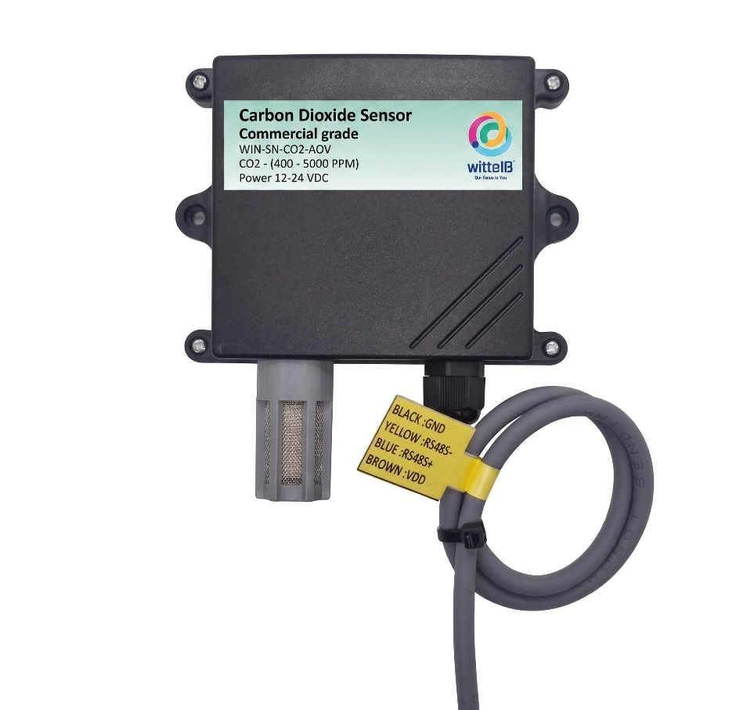

Ex: - Product Image

Sensor specification
 | Measuring Parameter | Measuring Range | Accuracy
☐ | Carbon Dioxide Measurement Range | 400 – 2000 PPM | ±50.0 ppm ±5.0 %m.v.
☐ | Carbon Dioxide Measurement Range | 400 – 5000 PPM | ±50.0 ppm ±5.0 %m.v.

2. Sensor Specifications
- Wide temperature range: −40 °C to +125 °C
- Full humidity range: 0 % to 100 % RH
- Power supply DC: 12-24V@1A.
- Product dimension: 85*85*36 mm.

- Certifications:

3. Power Supply Connection
DC Connection
- Use 12-24V@ 1A, Power supply.
- Don’t make loose connection.

4. Recommended Cable Electrical Characteristics
22 AWG Cable Shielded and twisted pair should be used.
Tinned Copper Recommended
Nominal Conductor DCR 14.7 ohm / 1000 ft
Nominal Capacitance 11 pf / feet (conductor to conductor)
High Frequency Non-Insertion Loss 0.5db / 100ft

5. Recommended Cable Electrical Characteristics
- Read all instructions before using the sensor board
- Keep the sensor board away from water or moisture to prevent damage.
- Do not disassemble or modify the sensor board.
- Use only the specified power sources and mentioned.

6. Analog Output AOC/AOV Specifications
- Measured Parameters: CO2 sensor.
- Output Type: Analog Output-10-bit and 12-bit resolution.
- Output Range: AOV 0-10V / AOC 4-20mA.
- Wide temperature range: −20 °C to +85 °C.
- Full humidity range: 0 % to 100 % RH
- Product dimension: 85*85*40 mm.
- Power supply DC: 12-24V DC @1A (Type –C power USB).


- Certifications:

Contact Information
Augmatic Technologies Pvt. Ltd.,
Plot no 6, Shah Industrial Estate II,
Kotambi,
Vadodara – 391510.
Email – Sales@wittelb.com
Support: support@wittelb.raiseaticket.com / +91 94038 92805

